Black Medick  (Medicago lupulina)  Flowers May to October. It is a nectar plant for many butterflies such as the Common Blue, Brown Argus, Gatekeeper and Meadow Brown. It will also attract moths and bees. | 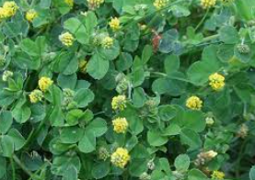
Bluebell  Almost half the world's bluebells are found in the UK, they’re relatively rare in the rest of the world. Bluebell colonies take a long time to establish - around 5-7 years from seed to flower.  They can take years to recover after footfall damage. If you plant bluebells, you should make sure it's the English bluebell, not the Spanish version. Spanish bluebells grow upright, with the flowers all around the stem, not drooping to one side like the British bluebell. They provide a great early food source for bees. | 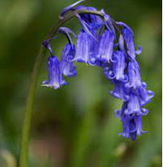
Borage  (Borago officinalis)  Borage, also known as star flower, is an old-fashioned plant that can get up to 2 feet. Repelling pests and attracting pollinators, it aids any plants it is interplanted with by increasing resistance to pests and disease. Bees absolutely love Borage. Its leaves, flowers and stalks are edible and taste a little like cucumber. Borage leaves are good in salads, yoghurt or cream cheese mixtures, or served with shellfish. | 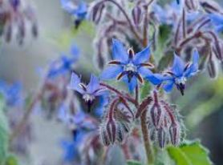
Broad Leaved Dock  (Rumex obtusifolius)  An abundant perennial, flower spikes appear from June to October. It is well-known as the herbal remedy for Stinging nettle irritations, yet there are differing opinions as to whether it really works or not. Broad-leaved dock is one of the foodplants of the caterpillars of the Small Copper butterfly. | 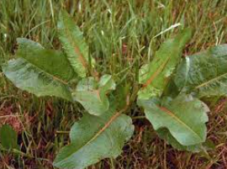
Cocksfoot Grass  (Dactylis glomerata)  Although normally grass pollen is not sought after by bees, it has been observed at Kew Gardens that Honeybees will favour this pollen above others from many flowers which are available at the same time. Bumblebees benefit from areas of long grass, as they build their nests in the ground in long grass, such as the moss carder bee, brown-banded carder bee, and red-shanked carder bees. The caterpillars of many butterfly species feed on cock’s foot. | 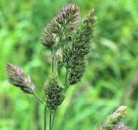
Columbine  (Aquilegia)  Columbine also known as Granny’s Bonnet prefers a dappled-shade. Its nodding, bonnet-shaped, flowers appear in May and June and will self-seed to provide a colourful and wild border, great for nectar-loving bees. Once started, columbine propagates for years, and although they are perennials, they also multiply rapidly by self-seeding | 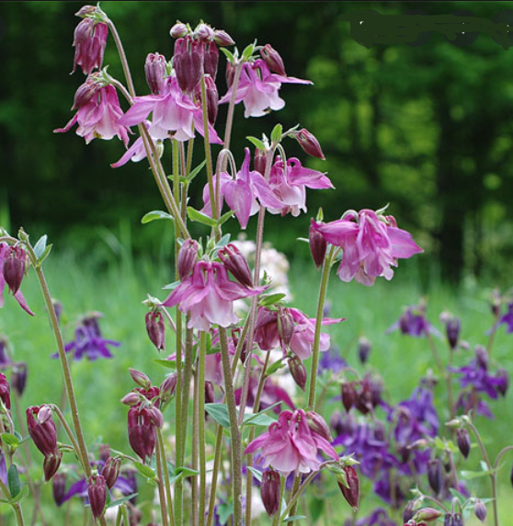
Common Daisy  (Bellis perennis)  The Common Daisy flowers from March to October, sometimes all year through the year if winters are mild, but mainly from April to June. The flowers attract bees due to their bright, white petals and yellow centre. | 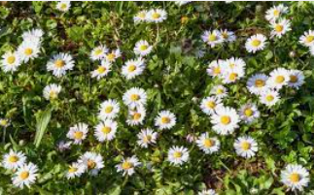
Common Mallow  (Malva sylvestris)  Large spreading plant with beautiful pink flower that appear June to October. The French word for mallow is 'mauve', which is where we get the word for the colour mauve from. It's loved by bumble bees, honey bees, and a good range of solitary bee species. | 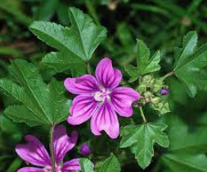
Corncockle  (Agrostemma githago)  Corncockle originated in Oxfordshire, England in the Iron Age. It is now virtually extinct in the wild. A herbaceous annual flowering plant which grow best in a sunny position in well drained soil. Corncockle is great for bees and other pollinators. | 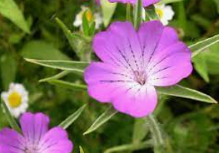
Cow Parsley  (Anthriscus sylvestris)  Likes shady habitats and has masses of frothy, white flowers May until June. Crushed between the fingers, the leaves produce a strong, aniseed-like scent. It is attractive to a huge number of creatures, from orange-tip butterflies, marmalade hoverflies and even rabbits. It’s a member of the carrot family. | 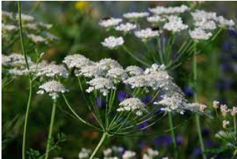
Creeping Bent  (Agrostis stolonifera)  Creeping bent lives up to its common name: its stems run along the ground before growing upright. Found on grasslands, damp arable fields and waste ground, it flowers between June and August. It is thought it hybridises with common bent and the resultant plant has developed a tolerance to heavy metal pollutants. | 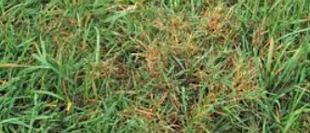
Daffodil  (Narcissus)  Perennial spring bulbs, said to symbolise friendship and new beginnings. Sadly most of the daffodils planted along roadsides have limited wildlife value. They same is true of narcissus. They tend to be avoided by bees. Daffodil stems produce a slime after cutting, which is harmful to other flowers so should be displayed in a separate vase. | 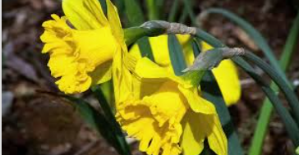
Dandelion  (Taraxacum officinale)  Dandelions pack a lot of vitamins and minerals into a small plant. “They're probably the most nutritionally dense green you can eat — outstripping even kale or spinach,” Geib says. Dandelion greens, are a great source of vitamins and minerals such as: Vitamins A, C and K. They are rich in both pollen and nectar, providing a great source of food for pollinators. | 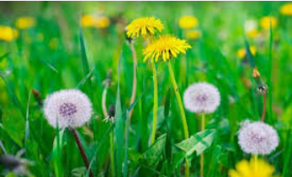
Field Woodrush  (Luzula campestris)  A common perennial plant of grassy areas where there are acidic conditions. Its dark brown, rounded flowers appear from April to May earning the common name of ‘Good Friday Grass’. It is also sometimes known as ‘Sweep’s Broom’ because of its brush like flowers.  It is one of the earliest flowering grass-like plants and although wind pollinated, the flowers are visited by hoverflies. | 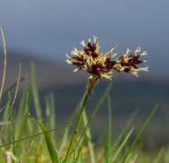
Forget Me Not  (Myosotis sylvatica)  Forget-me-nots are very hardy little plants that die back in winter but will re-sprout in spring. Plants that are at least a year old will flower the next spring. Their nectar and pollen are enjoyed by bumble bees and butterflies. | 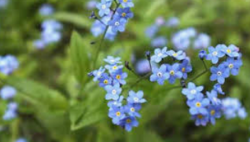
Garlic Mustard  (Alliaria petiolata)  Garlic mustard, also known as 'Jack-by-the-hedge', is a biennial flowering plant that likes shady places. It has small white flowers that appear from April. The leaves of are regularly used in salads, or as a flavouring for fish or meat. Very few insects or wildlife will readily feed on this plant. | 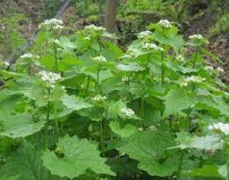
Germander Speedwell  (Veronica chamaedrys)  Considered a good luck charm for travellers as they grow in large clumps around hedgerows and verges. The flowers appear April to June. This plant is an excellent source of nectar for solitary bees. Its leaves are said to make a good tea effective in shifting a chesty cough. | 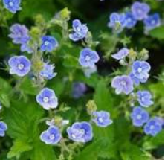
Goosegrass  (Galium aparine)  Common names include cleavers, clivers, catchweed and sticky willy among others. It is the small hooked hairs growing out of the stems and leaves which latch on, giving the name Sticky Grass or Sticky Willy. Geese particularly enjoy eating it – hence the nickname Goosegrass! Used medicinally, it’s an effective diuretic and effective for urinary issues. | 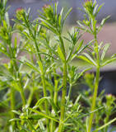
Ground Elder  (Aegopodium podagraria)  Also known as gout weed, bishop weed, jump-about. It spreads by underground stems (rhizomes) and can be very invasive, forming dense networks of rhizomes and roots underground. Compact umbels (umbrella-like clusters) of white flowers appear between June and August and are attractive to a range of insects. | 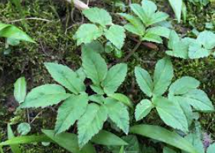
Herb Robert  (Geranium robertianum)  Herb-Robert is a nectar-source for many invertebrates including bees, hoverflies and the barred carpet moth. Traditionally used as an antiseptic, and treat stomach upset and nosebleeds. Its leaves are edible and used by some to make tea. They have also been used crushed and rubbed on the skin as an insect repellent. Other names, include red robin, death come quickly, fox geranium, stinking Bob, squinter-pip and crow's foot. | 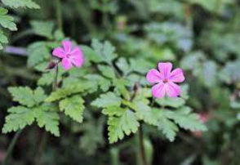
Hellebore  (Helleborus)  Hellebores are also known by their common names, Lenten rose, Christmas rose, winter rose, and bear's foot. Hellebores are a good source of spring nectar for honeybees. They're also handy plants for growing in the shadier spots of your garden. | 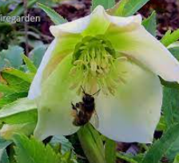
Hogweed  (Heracleum sphondylium)  Hogweed is a native plant (unlike its alien relative, giant hogweed) which is abundant in hedgerows, roadside verges, waste grounds and rough grasslands. As a member of the carrot family (an umbellifer), it displays large, umbrella-like clusters of creamy-white flowers between May and August (although it can flower all year-round) which are attractive to a range of insects. | 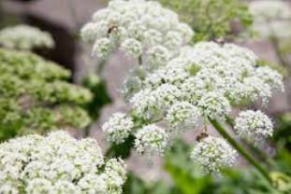
Ice Plant  (Hylotelephium specttabile)  Ice plant is an old-fashioned perennial with cabbage-like rosettes of succulent foliage throughout summer and autumn. This cultivar creates a striking feature in the autumn flower border with masses of flat, bright pink flower-heads on upright stems with succulent, glaucous leaves. When in flower, it is often buzzing with bees and butterflies. | 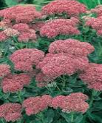
Love in a Mist  (Nigella damascene)  Flowering period is from June to September, when the love-in-a-mist blossoms are bound to attract plenty of bees and other helpful pollinators. The leaves are very finely divided and they encircle the flower like a feathery green collar, giving it the 'mist' part of the name. | 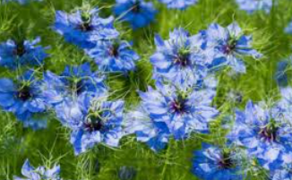
Marguerite Daisy  (Argyranthemum frutescens)  Flowers in early spring but disappear until the following spring if it goes below freezing. They are very attractive to butterflies and other pollinators. | 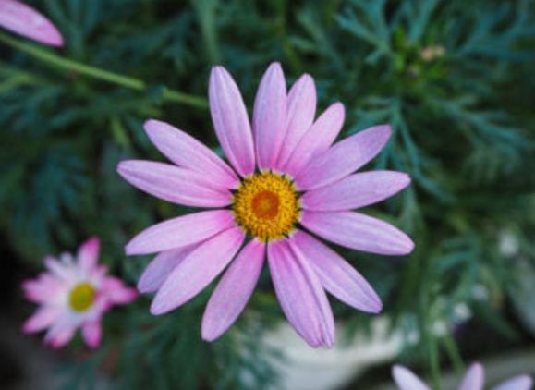
Meadow Buttercup  (Ranunculus acris)  Common perennial in meadows which prefers damper, calcareous sites. It flowers between April and October. They are common in grazed pastures as they are poisonous to grazing animals, so avoided. They have a chemical called protoanemonin in their sap. There is some evidence that they are harmful to bees who seem to avoid them. | 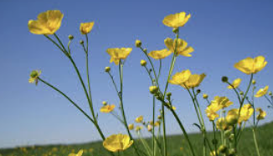
Oxeye Daisy  (Leucanthemum vulgare)  Grassland perennial plant thrives on verges, waste ground and hay meadows. Blooms July to September. They appear to glow in the evening hence the common name of ‘moon daisy’ or ‘moonpenny’. Attracts various pollinating insects, bees and beetles (e.g. snout weevils, tumbling flower beetles, longhorn beetles), hoverflies and caterpillars. | 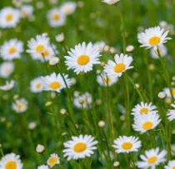
Periwinkle  (Vinca minor)  Grows best in partially shaded acidic soil. Periwinkle blooms April to May and is drought resistant. Known in folklore as the “flower of death” because its vines were woven into headbands worn by dead children or criminals on their way to execution. Toxic if eaten. | 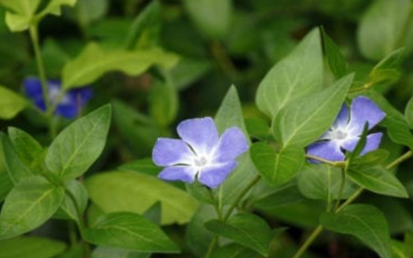
Pot Marigold  (Calendula officinalis)  Having Orange flowers that can be used in salads. Pot marigold a well-known plant, the petals can add orange colour to rice and other dishes, the petals have a delicate taste. They are very attractive to insects, especially butterflies that visit to drink nectar. Makes an ideal companion plant for Tomato, cucumber and asparagus plants as it helps repel: Tomato Worm, Asparagus Beetles, Whitefly. | 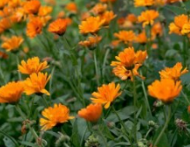
Primrose  (Primula vulgaris)  Primroses and primulas do best in partial shade, with moisture-retentive soil.  They can flower December to May. One of the first flowers of spring, these are an important nectar source for butterflies like brimstone and tortoiseshell. Primroses represent eternal love. | 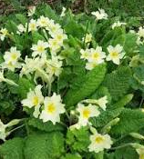
Ragwort  (Senecio jacobaea)  Common ragwort is one of the most frequently visited flowers by butterflies in the UK and more than 200 species of invertebrate have been recorded on it. The yellow flower heads are highly attractive to bees and other insects, including the black and red cinnabar moth. The flowering period is long, starting mid-June to November. Can be harmful if eaten by livestock. | 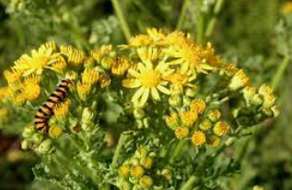
Red Campion  (Silene dioica)  Prefers partially shaded areas. The red campion is associated with Saint James as it flowers around his feast day. The flowers of red campion are important for various pollinating insects, including bees, butterflies and hoverflies. Traditional medicines used red campion seeds to treat snakebites. | 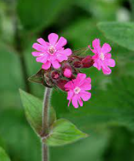
Ribwort Plantain  (Plantago lancelota)  It flowers between April and October. It attracts many small butterflies, moths and hoverflies and provides a good source of food for birds. Its seed heads remain for most of the winter providing food for goldfinches and other seed-eating birds. | 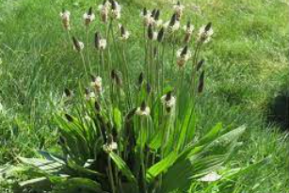
Rough Hawkbit  (Leontodon hispidus)  Similar to dandelion with each flower is on a long, leafless stem. A perennial which flowers June to October. The leaves, stem and buds are covered in numerous hairs. Very attractive to bees, insects and butterflies. | 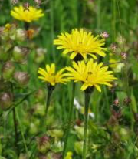
Salad Burnet  (Sanguisorba minor)  A low-growing herb of chalk grassland that produces rounded, reddish flower heads from May to September. Its leaves smell of cucumber if crushed, and this plant is a popular addition to salads and summer drinks. It is a favourite among herbalists for helping to heal wounds. Perfect for pollinators; its rich nectar attracts bumble bees, butterflies and other insects. | 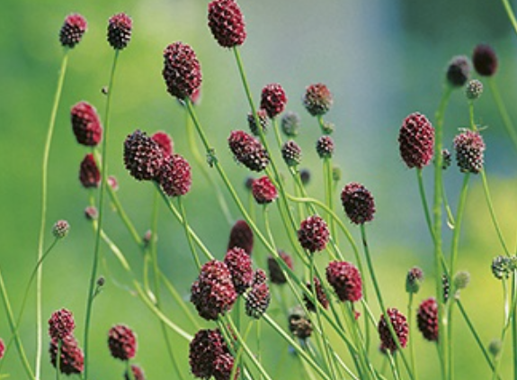
Smooth Meadow Grass  (Poa pratensis)  Found throughout the UK in meadows and traditional pastures. It is said to be one of the greenest grasses found growing in the early spring, and is an indicator of land that is well drained and in good heart. The species itself is palatable, and nutritional to livestock, often called one of the traditional 'sweet grasses'. | 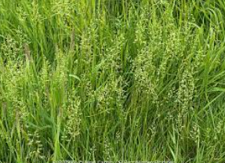
Sorrel  (Rumex acetosa)  Sorrel is a leafy green plant, use alternately as an herb and a vegetable, with a distinctive sour, lemony flavour, highly regarded in France. Other names for sorrel include spinach dock and narrow-leaved dock. | 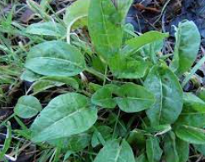
Stinging Nettle  (Urtica dioica)  Stinging nettle’s been used for hundreds of years to treat painful muscles and joints, eczema, arthritis, gout, and anaemia. Today, many use it to treat urinary problems in the early stages of an enlarged prostate. They are great wildlife attractors and the food plant for the caterpillars of red admiral, small tortoiseshell, painted lady and comma butterflies. Ladybirds feast on the aphids on them; and seed-eating birds enjoy their autumn spoils. | 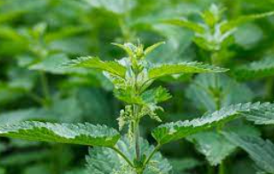
Timothy Grass  (Phleum pratense)  Robust perennial grass characterised by its long, cylindrical flower heads. It is also known as meadow cat's-tail. It gets its name from Timothy Hanson, who promoted the grass in the 1700s as a pasture grass. It is most often used for cattle and horse feed. | 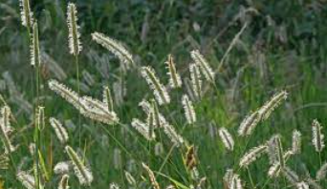
Tulip  (Tulipa)  Perennial spring bulb. As a general rule, Tulips can attract bees as they bloom early in the season and have vibrant colours. Tulips don’t have much nectar to offer to the bees, but some tulip varieties bloom in the early spring, providing some food to the bees who have come out of hibernation. | 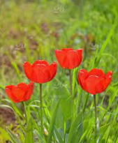
Wall Rue  (Asplenium ruta-muraria)  Wall-rue is an easily recognisable fern, with club-shaped leaflets that appear in groups of three on the frond. One of the commonest ferns on walls, it can be seen growing in tufts out of old mortar. This provides food and shelter for minibeasts. | 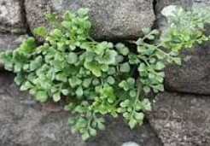
Wood False Broom  (Brachypodium sylvaticum)  Wood false-brome, is a perennial grass which typically grows in shade as distinct tufts or clumps of long wide flat green leaves which droop down at the edges of the tufts. It is quite an ornamental grass. The foliage tufts are typically up to 30 cm height. The flowering stems arch up out of the tufts to 90cm with drooping heads which can persist into winter in sheltered positions. | 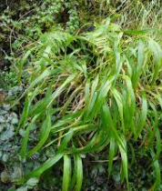
Wood Sedge  (Carex sylvatica)  Carex sylvatica is a species of sedge found in deciduous woodlands across Europe. Recommended as a groundcover under trees and shrubs. | 