DAVE GOULSON’S 16 BEST GARDEN PLANTS FOR POLLINATORS
- Bush vetch, Vicia Sepium
- Catmint, Nepeta racemose
- Plume thistle, Cirsium rivulare
- Comfrey, Symphytum officinale
- Dahlia, Bishop of Llandaff
- Field scabious, Knautia arvensis
- Meadow cranesbill, Geranium pratense
- Giant Hyssop, Agastache foeniculum
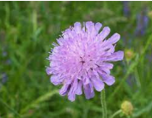
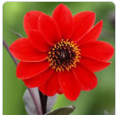
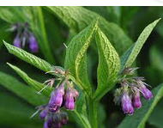
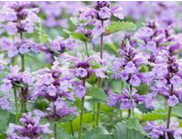
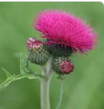
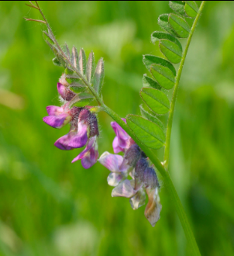
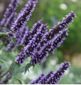
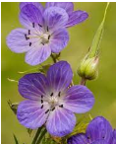

- Lavender, Lavandula intermedia
- Lungwort, Pulmonaria
- Marjoram, Origanum vulgare
- Pussy Willow, Salix caprea
- Sicilian honey garlic, Allium siculum
- Sneezewort, Helenium
- Thyme, Thymus polytrichus
- Viper’s bugloss, Echium vulgare
