Statement of Significance

Introduction
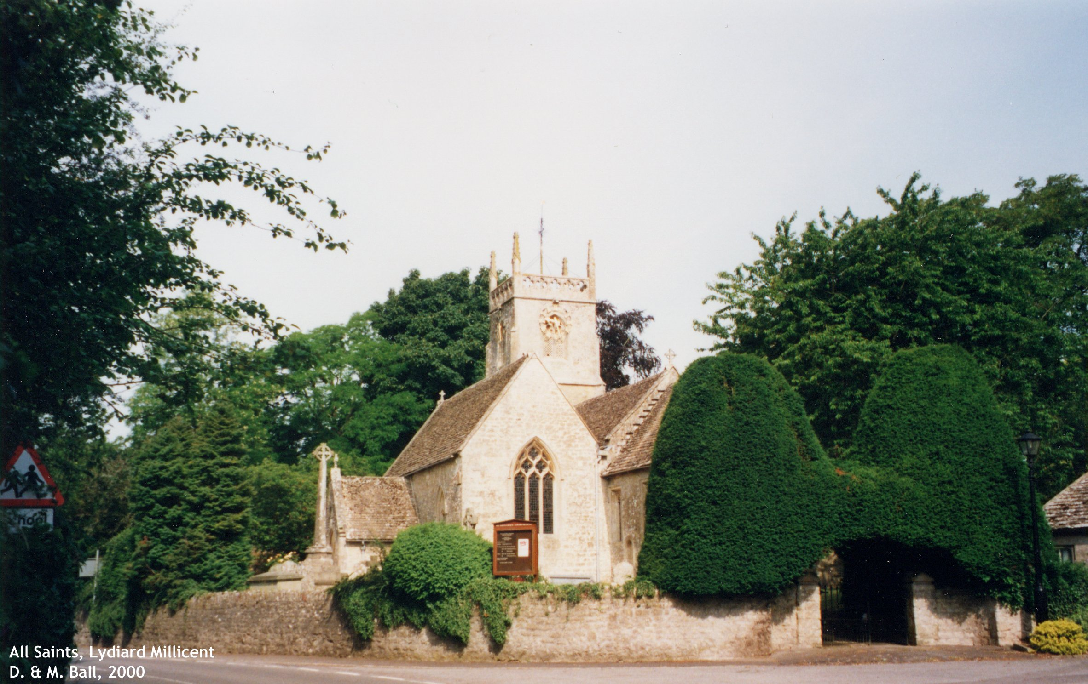
Lydiard Millicent is still very much a community in its own right despite being just a few hundred yards from Swindon's western border. The village centres on the crossroads of ancient trade routes, a pond and the charming parish church of All Saints. The village is a mixture of ancient stone farmhouses, older cottages and newer in-fill developments. Like Swindon, it has grown enormously over the last 50 years, more than tripling in size to a population of about 1,500. The village's origins go back at least as far as the Domesday Book of 1080 when there is a mention of Lydiard Manor. This was owned by the Norman knight Geoffrey de Clinton and his descendants until 1429 when it was sold to Robert Andrews. In 1457 Robert Turgis became Lord of the Manor and he rebuilt it from scratch. The house he built remained until 1880 when it was destroyed by fire, then rebuilt in the 1960s.
Nikolaus Pevsner’s “The Buildings of England (Wiltshire)” records the following details in respect of the church:
Decorated South Arcade, low, with octagonal piers and double-chamfered arches starting on big vertical pieces. Decorated South Aisle windows. East reticulated tracery (typical of early 14th Century consisting entirely of circles drawn at top and bottom into ogee shapes – double curve, bending first one way and then the other - so that a net like appearance results).
Single framed nave roof. Perpendicular West Tower with Somerset tracery in the bell openings, a parapet with openwork quatrefoils (four lobes formed by the cusping of a circular or other shape in tracery), and pinnacles.
Perpendicular Chancel much restored in 1871.
Straight headed North and South Windows; ceiled wagon roof (a roof in which closely set rafters with arched braces give the appearance of the inside of a canvas tilt over a wagon).
Overdoor (sopraporta; relief work), naïve Gothic dated 1857.
Stained glass; bits in the head of the North Window.
Monument: Ferdinand Askew; grey and white marble.

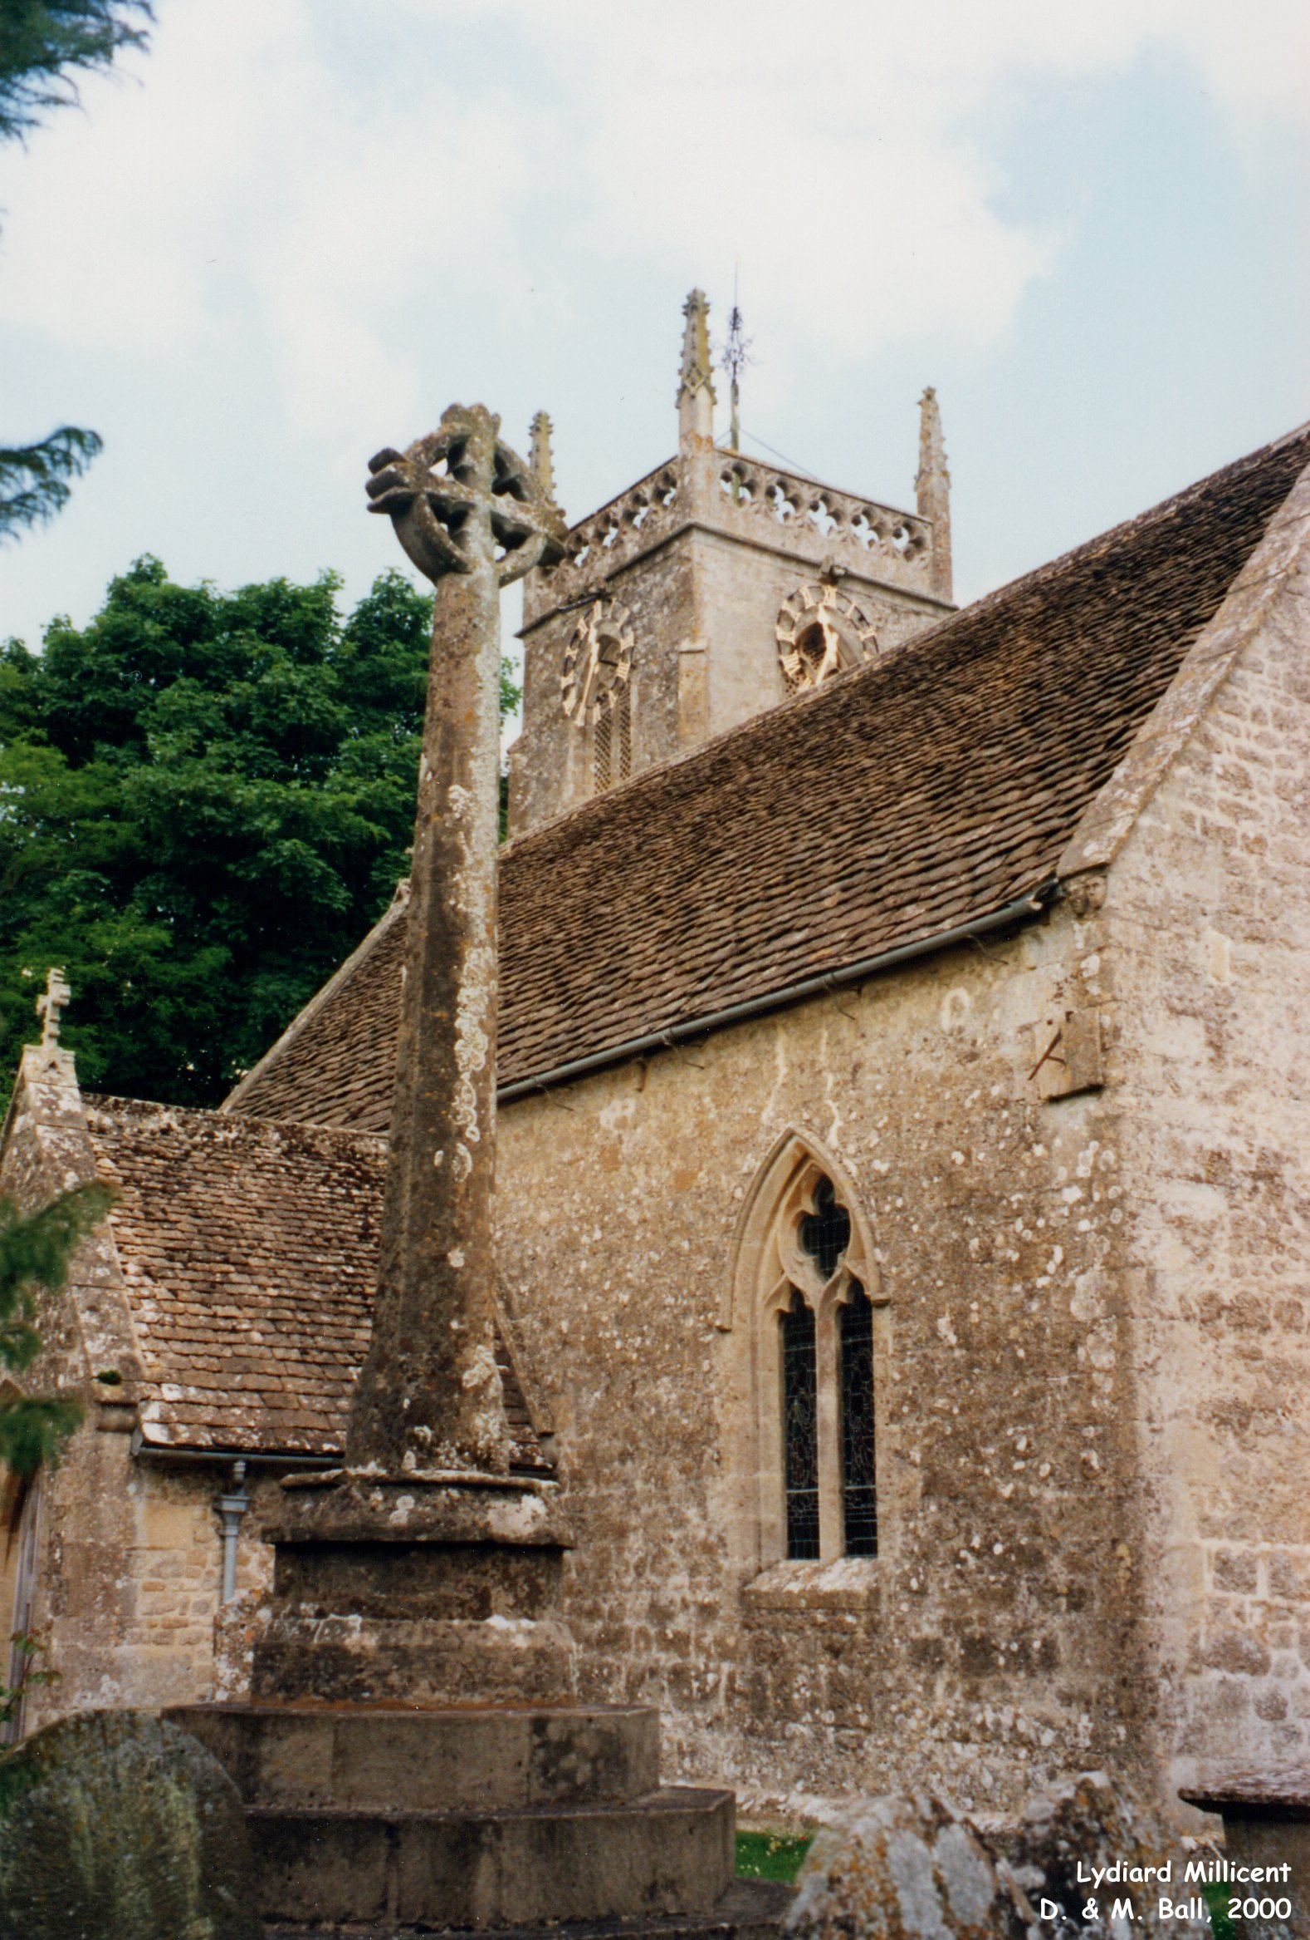
All Saints is Grade II* listed. The church sits in relatively small grounds, bordered on East and South sides by roads and stone walls of unknown age. The North and West brick boundary walls date from 1715. Entrance to the grounds, is either via a set of stone steps to the South, or a gate with a Yew archway, which dates back to around 1900. The clock on the bell tower was installed as a war memorial after WWII. On the Southern part of the grounds many headstones and tombs survive, albeit in increasingly poor condition, 6 of which are listed and go back to 1707. Some details follow.

Churchyard Monuments
Of most historical significance is the churchyard cross, (Medieval and 19th Century. Limestone. Octagonal shaft, returning to square at the base. Coped octagonal base. All set on three 19th Century high steps and provided with wheel-cross head). The shaft is believed to be Saxon and was probably the baluster mullion of a window of that period, providing some hint to the existence of a pre-Norman church. The cross is listed (Grade II).
Lydiard Millicent War Memorial, which stands in the churchyard of the Church of All Saints, is listed at Grade II. The listing details include the following; “a simple yet poignant memorial cross; unusually, the memorial has not been adapted for Second World War commemoration, and thus retains its original design intent”.
The Millington Monument, 5 metres south of the South Porch, is Grade II listed. It is a late 18th Century Chest Tomb made from Limestone. It has a moulded table and chamfered base set on stone paving. Its sides are plain with the inscription to FRANCES MILLINGTON, died 1776.
The Templer Monument, 3 metres west of the tower is Grade II Listed. It is a mid-18th Century Chest Tomb made from Sandstone. It has a moulded table and chamfered base with recessed corner balusters. The inscription is to WILLIAM TEMPLER, died 1766, and wife JANE, died 1743.
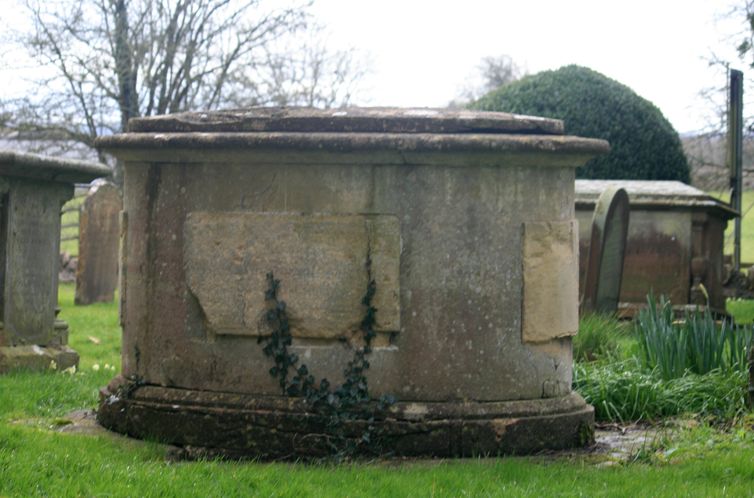
A pair of unidentified monuments in the churchyard, 5 metres north of the chancel are Grade II listed. They are a pair of 18th Century Chest Tombs made from Limestone. They have chamfered tables with weathered inscriptions, low plain sides with incised end pilasters and verse. The base is probably concealed.
The oval monument in the churchyard, 3 metres south-west of the aisle, is Grade II listed. It is an 18th Century oval Chest Tomb. C18 made from Limestone. It has a moulded table with raised centre and moulded base on paving. It has four raised panels, one bearing an inscription to WILLIAM DO.... (illegible).

The Bewley monument in the churchyard, 4 metres west of the South Porch is Grade II listed. It is an early 19th Century Chest Tomb made from fine Sandstone. It has a moulded table and chamfered base and plinth with recessed corner balusters. There are fine inscriptions to BENJAMIN BEWLEY, died 1808 with bas relief trees and urn. Also, his wife MARTHA added 1829, son 1836 and daughter, 1837.
Headstones in the northern grounds have been uplifted and the area is now grass. The churchyard was closed for burials in 1885. In May 1977, the church grounds were closed for the burial of cremated remains.

Building Developments
Over the years All Saints Church building in the village of Lydiard Millicent has undergone many changes. The records available to us at this time only go back to the 1800s and can be found in the Wiltshire and Swindon History Centre in Chippenham.
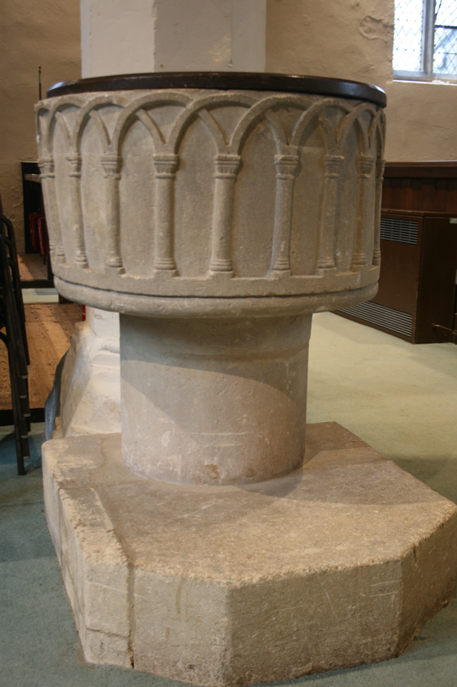
The earliest documentary record of the building goes back to somewhere between 1066 and 1075, when William FitzOsbern, Earl of Hereford and owner of Lydiard Millicent Manor endowed his possessions in England to the Abbey of Cormeilles, part of which was the Church of Lydiard Millicent, although little evidence exists of a building before the 14th century. Entering the church through the South porch, you arrive in the south aisle which is 14th century, recent dendrochronology has dated a roof timber as being cut down in 1341 and used by 1345. Straight ahead is the oldest internal feature, the circular Norman font with interlaced arches, dating from mid to late 12th century.
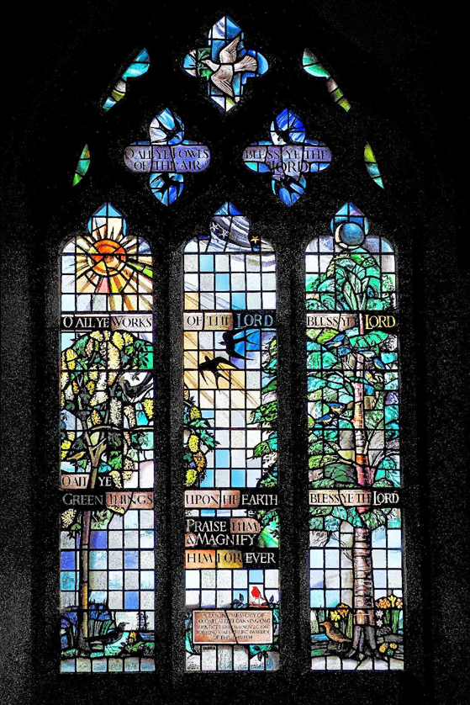
Norman Font
Beside the priest’s chair is a “Squint” or “Hagioscope” cut at an angle in the stone pillar which gave the congregation in the South Aisle a view of the high altar during Mass and allowed them to witness the solemn act of the elevation of the Host. There is a piscina in the Chancel and another in the South Aisle.
The east window is a stunning piece from the much renowned Margaret Edith Aldrich Rope, 1891 to 1988 ("Tor") installed in 1963. This was one of her final commissions. (More detailed research is available on the window if required).
The nave and 2/3 of the chancel are 15th century, probably around 1457, when Turgis was granted a royal licence to rebuild the Parish Church, and the tower a little later. In the 15th century the nave was reroofed and given large perpendicular windows. The chancel has a blocked priest’s door on the south side.

New Pews
In 1847 the population of the village had increased to 564 and the church only seated 160. The parishioners wanted to increase the seating to 225 seats. They proposed to do this by removing the old pews and using the timber to make new pews. There are drawings of these new pews which are clearly the pews in the church today.
A Pew Report produced by Oxford Heritage Partnership in May 2021 considered the main pews to be of moderate to low level of importance, while the choir pews were considered to be of moderate to high importance.

Renovation to chancel
In 1870, due to an absentee vicar the chancel had fallen into disrepair and the vestry members asked for permission to extend it and to put in steps to a boiler room. This involved excavations which lead to the original boiler room and the creation of steps down to it. Any human remains moved during excavations were to be reburied with the vicar present to ensure they were replaced with care and in a seemly manner. Not sure who did this due to the absence of the vicar but there were obviously clergy in the area who attended to such matters.
There are extensive plans and architect’s instructions about this work although some of which have been photographed. Please note that in the architect’s drawings the organ is in front of the present vestry and the choir stalls are in the traditional position at right angles to the congregation. These choir stalls or pews are presently at the back of the church near the organ. Thus, the end 1/3 of the chancel dates to 1870 when an extension was added, retaining the 15^{th-}century east window.

The East Vestry
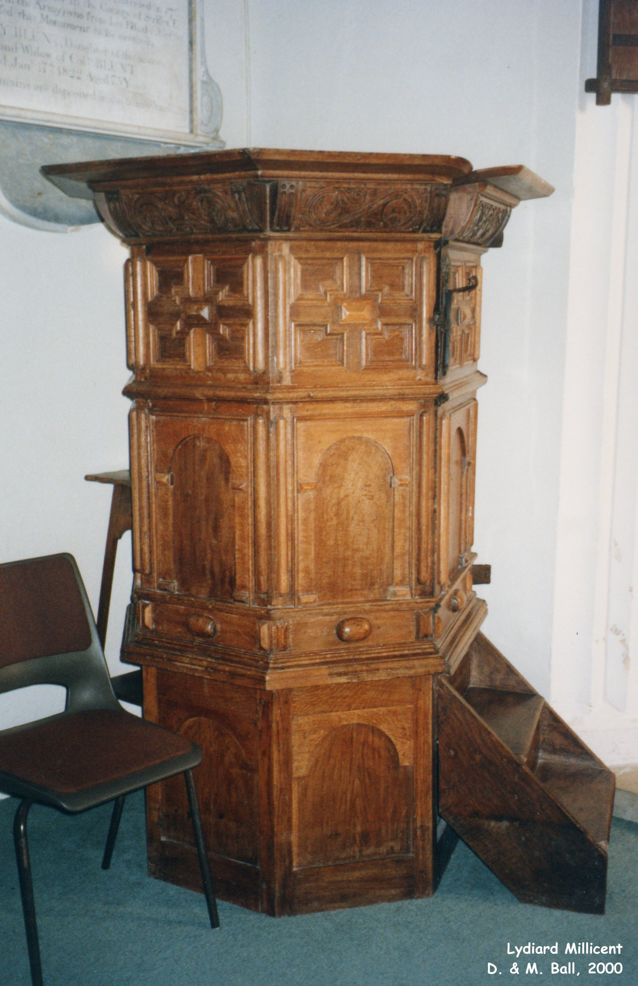
The vestry contains a Saxon frieze, found in the wall infill during the 1870 extension. There are two wall monuments in the Vestry in white and grey marble; one high up on the wall above the cupboards and another partially obscured. The vestry carpet is estimated to have been installed around 20-25 years ago and below this are Victorian tiles.

The Pulpit
The original pulpit was removed by Revd McKnight and given to the little church at Braydon and replaced by his pupil’s work. The pulpit, currently stands at the NE end of the chancel, is Jacobean and has had a nomadic life, spending around 100 years in Braydon church while Mr McKnight’s Victorian one (exceedingly elaborate Victorian Gothic, carved by local boys under the supervision of the curate in 1862) had pride of place, this appears to have been recycled into other pieces of church furniture. At some point, the original pulpit was returned and is found to the right of the communion table in the chancel. This was originally a temporary move but has been in its present position for over 15 years. The pulpit is not currently in use.

Tower and Bells
In 1553 there were three original bells. The western tower now contains 6 bells, the oldest three bells date from 1712 and were cast by the elder Abraham Rudhall of Gloucester (1657 to 1736), two more were put in place in 1906 and a third in 1932, these were restored in 2003. The organ, built in Bibury Church in 1868 by “Mr. Nicholson of Worchester” and restored in 1964, sits in the base of the tower.

Organ
In 1962 the organ was found to be in disrepair and so in 1964, it was replaced with an old organ from Bibury church, (built in 1868 by Mr. Nicholson of Worcester) and bought at a cost of £50 (although it cost £750 to rebuild and install). This organ is said to be of no historic significance. When it was installed, it was moved from the chancel to the bell tower and the west vestry screen was moved to the chancel. It is said (Wiltshire Community History) that this rearrangement arose because the replacement organ was three inches too wide.

Floor and Steps
In 1966 some work was carried out to the chancel steps and part of the nave floor. The new steps and paving were made of Cotswold Dales Reconstructed Stone and installed by Messrs Smith & Hope Ltd, Building Contractors of High Street, Wootton Bassett, Wilts for the sum of £497.12.00.

Circulating Space (Creche area)
In 1986 further changes were made to the building when the pews at the rear of the south aisle were removed, shelving was installed (some of the wood from the pews was used to make the new furniture). It also houses the church library, notice board and resource centre.

Porch and New Doors
Also, in the plans of 1986 are drawings for a new door to the porch – the present wooden door. Plans were also made to replace the green baize door with a glass door but for some reason, this work was not carried out.

Side Altar
The side altar was installed in 1947 from the oak obtained from removed pews. In 1994 temporary changes were made to the communion table in the side aisle. The table was moved forward and a curtain was removed. Since these changes remain it is to be assumed that the changes were later made permanent. (See document: notes of temporary reordering).

Windows
In addition to the east window by Margaret Edith Aldrich Rope installed in 1963, there are 4 other stained-glass windows.
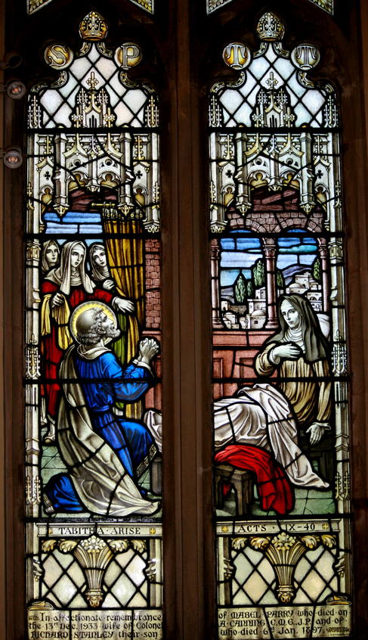
A fine stained-glass window installed in the main west window.
1934 – stained-glass window installed in Memory of Mabel & Richard Canning.
1951 – stained-glass window installed in memory of Edwin and Sarah Newman.
1963 – stained-glass window installed in memory of Col. Canning.
There are relics of more ancient glass at the top of some of the plain windows.

Other Changes
Although we have not been able to find any documents relating to some of the other Victorian changes it is clear that Revd McKnight’s pupils made and installed the frame around the baize door, a pulpit (which has since been removed), a wooden lectern and other dark wood additions to the building. Much of this has been removed or re-purposed (as in the altar frontal box). They may also have made the main communion table. It appears that Revd McKnight’s pupils enjoyed many woodwork lessons, but their work is in no way expert.

Carpeting
The red chancel carpet (Chinese carpet) was donated by E Smith in memory of his daughter Elizabeth in 1980. The colours and were chosen and approved by the diocese as it reflected the colours in the chancel roof. The carpet has a large split where it is laid across the chancel steps.
The green carpet which covers the main body of the church was laid in 1996. This has been damaged and stained in a number of places.

Sound System and Lighting
A sound system, with radio microphones and hearing aid induction loops was installed in 1996 and updated in 2004. A new sound system was installed in 2019 and two AV Screens were installed. These, along with a projector are attached on a platform to one of the internal columns. New lighting was installed in 2018.

Vault under the Nave
Under the nave, adjacent to the font, is the Kibblewhite vault, which contains 18 interments from 1814 to 1895.

Stone Vault West of the Font
Although not presently visible due to the carpet there is apparently a stone vault west of the font on which is inscribed the following; JACOB HICKES MEDICUS Beatam Resurrectionem ultimo die expectaus ex hoc vita demigrarit die marche amo XI nostrae redemptionus. CI)I) CLXXIX
It is unclear if this is the only stone (there is another in the porch) or if it marks a burial or simply is a memorial stone. We are not aware of any documentation relating to burials.
A series of photographs of the interior of the church are set out below:

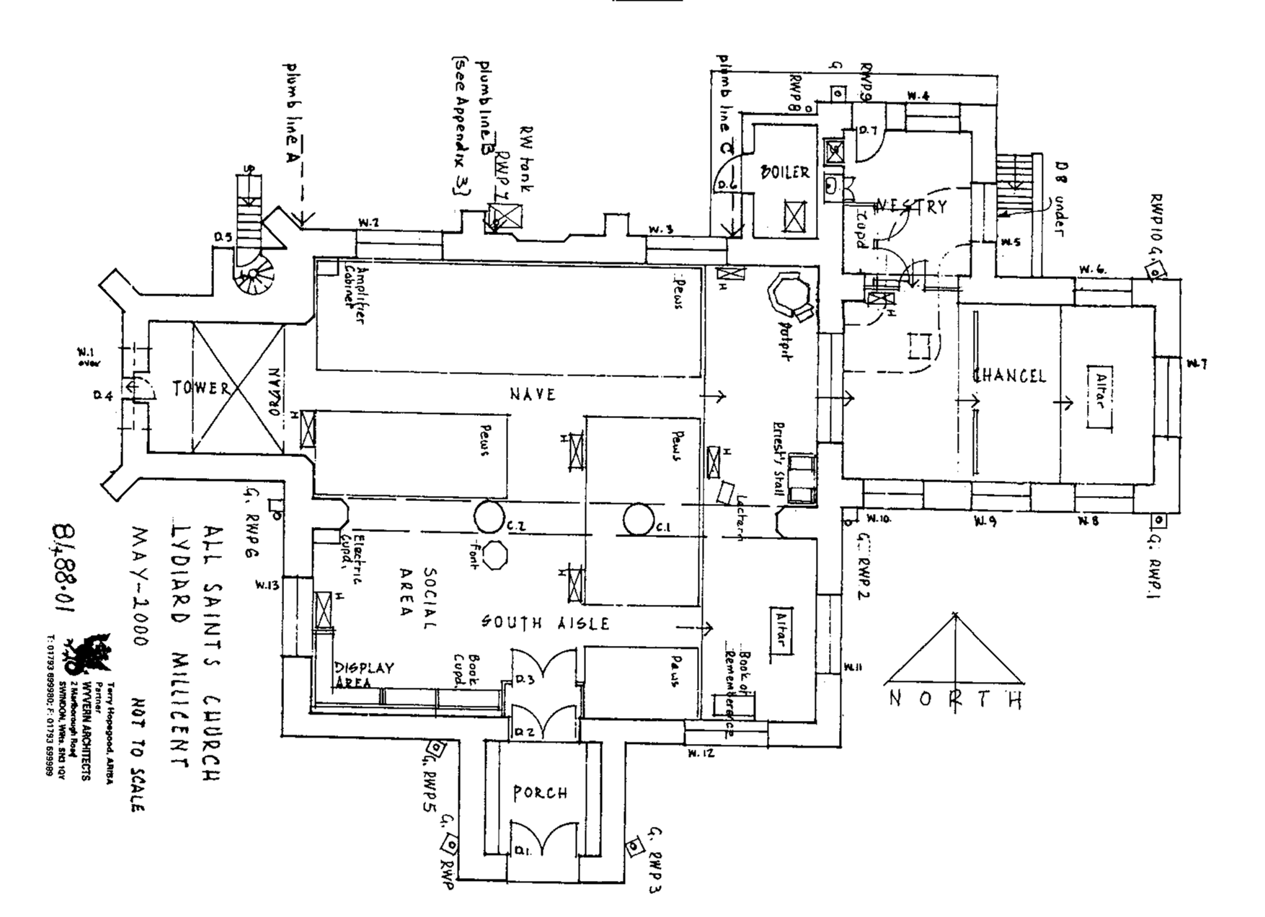

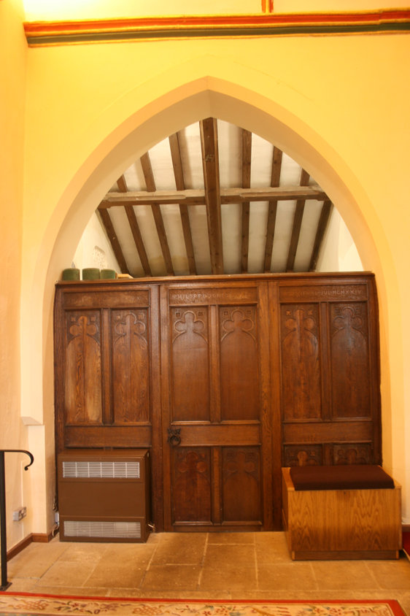  Door to the vestry | 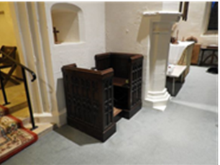  Preachers’ pew | 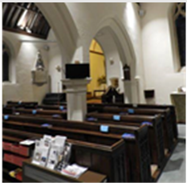  View facing North East
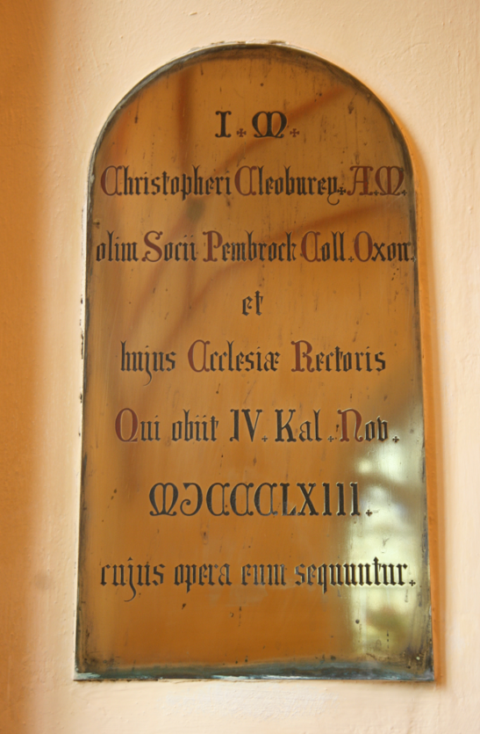  Monument | 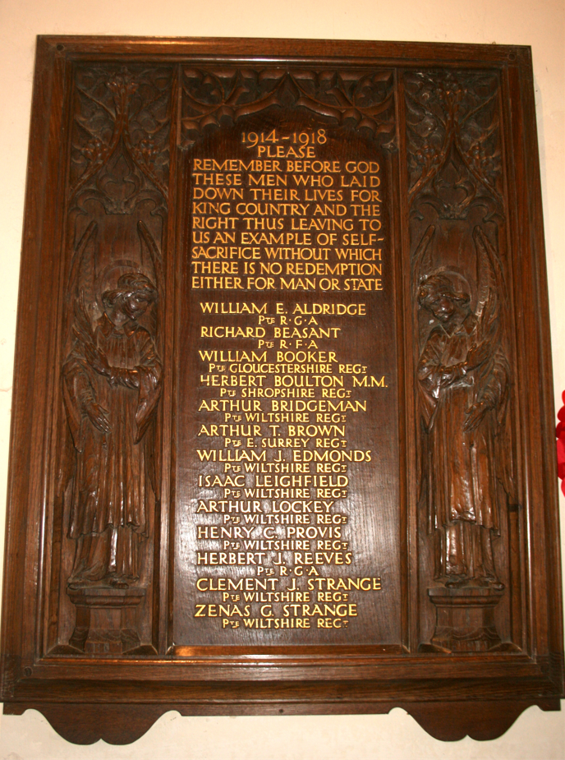  Monument to those who died in WW1 | 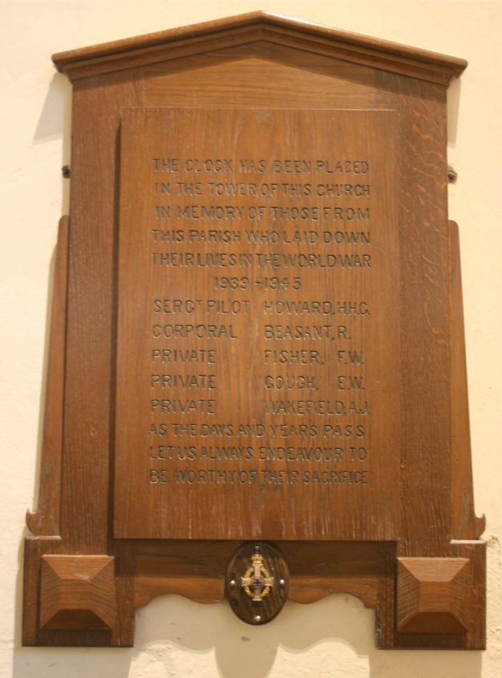  Monument to those who died in WW2
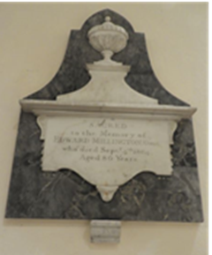  Monument | 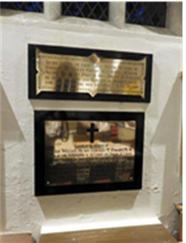  Monument | 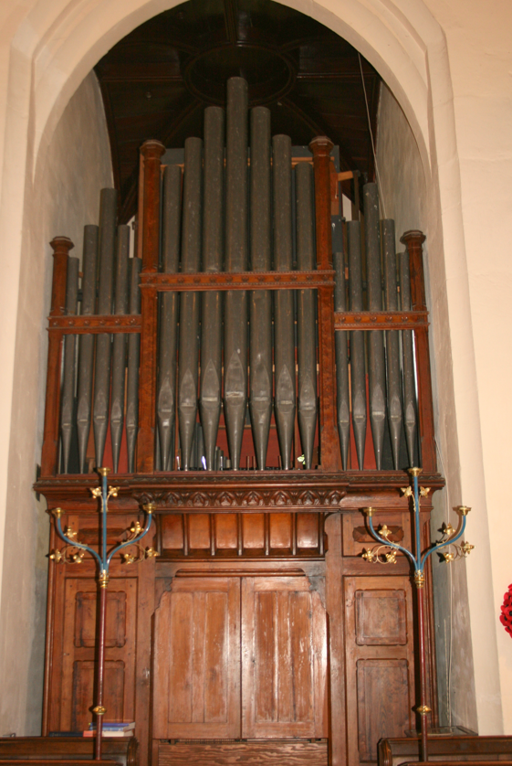  Organ
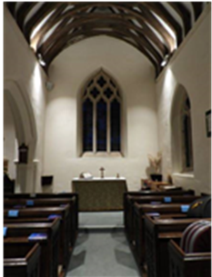  South Aisle facing North East | 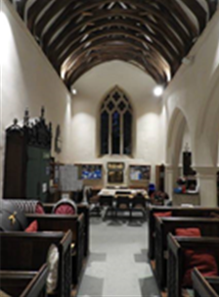  South Aisle facing North West | 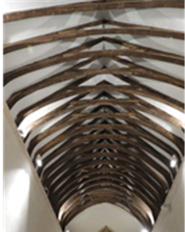  Nave Roof

